(Your Business Name Here) – Safe Work Procedure

BLOWER VACUUM – ELECTRIC

DO NOT use this machine unless you have been instructed
in its safe use and operation and have been given permission

PERSONAL PROTECTIVE EQUIPMENT

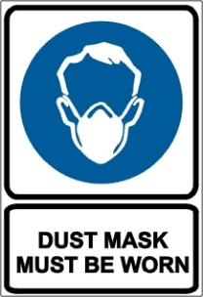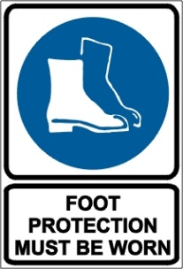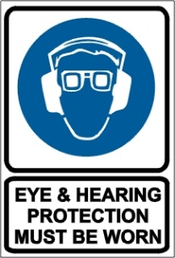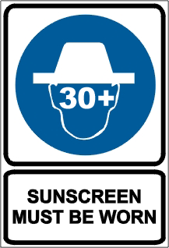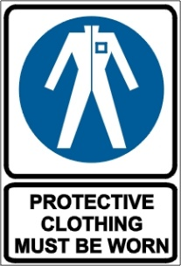

PRE-OPERATIONAL SAFETY CHECKS
- Locate and ensure you are familiar with all machine operations and controls.
- Check for loose/missing nuts, bolts and screws. Tighten and/or replace as needed.
- Inspect the parts of the mulching cutting head (where fitted). Replace cutting line if worn or damaged.
- Ensure the debris bag is in sound condition and is properly fitted with no gaps.
- Ensure all guards are fitted, secure and functional. Do not operate if guards are missing or faulty.
- Ensure the machine and extension cord are tagged and are current.
- Ensure the extension cord is in good condition and fully uncoiled.

OPERATIONAL SAFETY CHECKS
- Ensure no person or animal is endangered when operating equipment.
- Adjust the shoulder harness to ensure it is in the most comfortable position.
- Keep a firm grip. Hold handles with fingers together encircling handles.
- Maintain a straight wrist position. Avoid using your wrist in a bent, extended or twisted position.
- Maintain a proper balance and secure footing. Do not stand on slippery, uneven or unstable surfaces. Do not work in odd positions or on ladders.
- Select the mode indicator to adjust the nozzle position for blow or vacuum.
- Take wind conditions into account. Avoid open doors and windows.
- Minimise dust by using blower at lower speeds.
- If the blower vacuum starts to vibrate unusually, switch off and check immediately.

ENDING OPERATIONS AND CLEANING UP
- Switch off and disconnect from the electricity supply before removing or replacing the debris bag.
- Remove any foreign material from in and around the motor air inlet and nozzle.
- Keep the work area and implement shed in a safe, clean and tidy condition.

POTENTIAL HAZARDS
- Noise.
- Electrical hazards.
- Flying debris.
- Dust.

DON’T
- Do not use faulty equipment. Immediately report suspect machinery.
- Do not use in wet conditions.
- Do not wear jewellery or loose clothing that can be drawn into the air inlet.
- Do not pull cable around sharp objects.
- Do not direct the blower towards other people.
- Do not place hands in bag when emptying. Sharp debris can cause injury.

This safe work procedure does not necessarily cover all possible hazards associated with this equipment and should be used in conjunction with other references.
It is designed as a guide to be used to compliment training and as a reminder to users prior to equipment use.

ALWAYS refer to the manufacturer’s instructions when writing your own safe work procedure.

.

