(Your Business Name Here) – Safe Work Procedure

WALK BEHIND MOWER

DO NOT use this machine unless you have been instructed
in its safe use and operation and have been given permission

PERSONAL PROTECTIVE EQUIPMENT

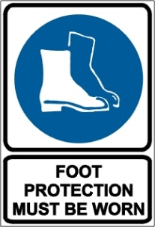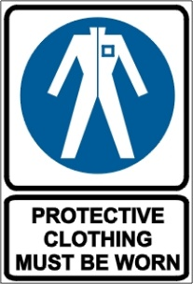

PRE-OPERATIONAL SAFETY CHECKS
- Locate and ensure you are familiar with all machine operations and controls.
- Ensure mower is clean.
- Ensure all guards are fitted, secure and functional. Do not operate if guards are missing or faulty.
- Ensure cutting blades are sharp, secure and in good condition.
- Check for any loose, broken, missing or damaged parts. Replace as needed.

OPERATIONAL SAFETY CHECKS
- Clear the area to be mowed of debris that may be thrown.
- Watch for ejected material. Ensure no person or animal is endangered when operating equipment.
- Avoid mowing in wet conditions due to lack of traction.
- Maintain a proper balance and secure footing.
- Keep clear of moving machine parts.
- Operate at a speed slow enough to keep control over unexpected hazards.
- Mow in a forward direction.
- When mowing on a slope, mow across the slope. This keeps a better distance between you and the mower in case of a slip.
- Allow the mower to cool before refuelling.

ENDING OPERATIONS AND CLEANING UP
- Turn off the fuel supply when work completed.
- Remove any foreign material from in and around engine and catcher parts.
- Before adjusting or clearing grass clogs, shut off the mower, remove the spark plug lead and allow it to come to a complete standstill.
- Keep the work area and implement shed in a safe, clean and tidy condition.

POTENTIAL HAZARDS
- Noise.
- Rapidly rotating cutting blades.
- Ejected material and flying debris.

DON’T
- Do not use faulty equipment. Report suspect machinery immediately.
- Never leave the machine running unattended.

This safe work procedure does not necessarily cover all possible hazards associated with this equipment and should be used in conjunction with other references.
It is designed as a guide to be used to compliment training and as a reminder to users prior to equipment use.

ALWAYS refer to the manufacturer’s instructions when writing your own safe work procedure.

