(Your Business Name Here) – Safe Work Procedure

LINE TRIMMER - ELECTRIC

DO NOT use this machine unless you have been instructed
in its safe use and operation and have been given permission

PERSONAL PROTECTIVE EQUIPMENT

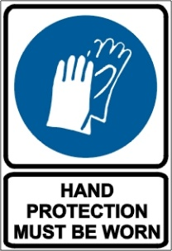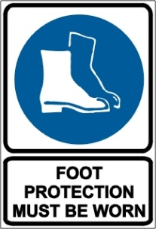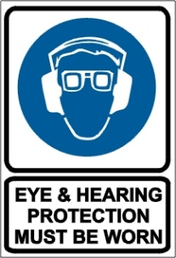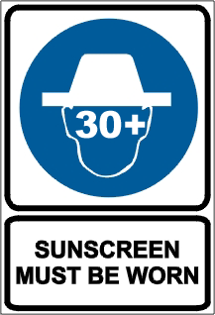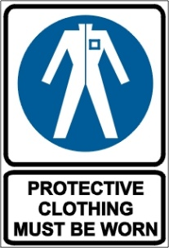

PRE-OPERATIONAL SAFETY CHECKS
- Locate and ensure you are familiar with all machine operations and controls.
- Ensure all guards are fitted, secure and functional. Do not operate if guards are missing or faulty.
- Ensure the nylon line cutter is functional.
- Load the nylon line cutting head only with nylon trimmer line of the proper diameter.
- Ensure the cutting head is tightened.
- Ensure the harness (if fitted) is in sound condition.
- Ensure the machine and extension cord are tagged and the tags are current.
- Ensure a tagged and tested RCD is used when operating the machine. Trip test the RCD before use.
- Ensure the extension cord is in good condition and fully uncoiled.

OPERATIONAL SAFETY CHECKS
- Adjust the handle to a position for comfort and good balance.
- Maintain a straight wrist position. Avoid using your wrist in a bent, extended or twisted position.
- Take periodic breaks to minimise repetition and rest your hands.
- Watch for ejected material. Ensure no person or animal is endangered when operating equipment.
- Maintain a proper balance and secure footing. Do not work on slippery, uneven or unstable surfaces.
- Ensure extension cable is well clear of cutting head at all times.
- Always keep both hands on the control handles.
- Keep clear of moving machine parts.
- Keep clear of fences, wires, posts and rocks to prevent kick out and cutting head damage.

ENDING OPERATIONS AND CLEANING UP
- Remove any foreign material from in and around from motor, cutting head and guards.
- Keep the work area and implement shed in a safe, clean and tidy condition.

POTENTIAL HAZARDS AND INJURIES
- Ejected materials.
- Hair/clothing getting caught in moving machine parts.
- Vibrating machinery.
- Electrical hazards.

DON’T
- Do not use faulty equipment. Report suspect machinery immediately.
- Do not use in wet conditions.
- Do not raise the line head above knee height.

This safe work procedure does not necessarily cover all possible hazards associated with this equipment and should be used in conjunction with other references.
It is designed as a guide to be used to compliment training and as a reminder to users prior to equipment use.

ALWAYS refer to the manufacturer’s instructions when writing your own safe work procedure.

