(Your Business Name Here) – Safe Work Procedure

TRACTOR

DO NOT use this machine unless you have been instructed
in its safe use and operation and have been given permission

PERSONAL PROTECTIVE EQUIPMENT

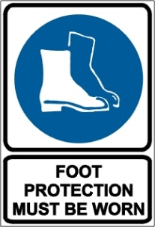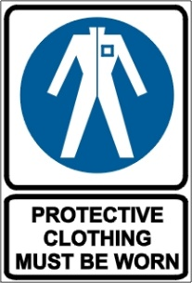

PRE-OPERATIONAL SAFETY CHECKS
- Locate and ensure you are familiar with all machine operations and controls.
- Ensure all guards are fitted, secure and functional. Do not operate if guards are missing or faulty.
- Ensure the seatbelt, roll over protective structure (ROPS), falling objects protective structure (FOPS) (where fitted) and power take-off (PTO) guard are in sound condition.
- Ensure the 3 point linkage, pneumatic and hydraulic systems are functioning.
- Use only implements that meet the manufacturer’s recommendations.
- Before starting the tractor, ensure all levers are in their neutral positions, the parking brake is engaged and the clutch and PTO are disengaged.
- Ensure you are trained and competent and if driving on public roads, appropriately licensed.
- If the tractor is used on public roads, ensure all lights and warning devices are functioning and the vehicle is registered.

OPERATIONAL SAFETY CHECKS
- Pull only from the drawbar or hitch.
- Drive at speed slow enough to keep control over unexpected hazards.
- Always reverse when going up a steep slope. Avoid slopes that are too steep for safe operation.
- Ensure no person or animal is endangered when operating equipment.
- Ensure bucket (if fitted) is raised above line of sight.

ENDING OPERATIONS AND CLEANING UP
- When stopping the tractor:
- Park on even ground, disengage the PTO and lower all implements.
- Place all control levers in their neutral positions, apply the parking brake, turn off the engine and remove the keys.
- Ensure the tractor has come to a complete stop before dismounting.
- Remove any foreign material from in and around engine and implement parts.
- Keep the work area or implement shed in a safe, clean and tidy condition.

POTENTIAL HAZARDS
- Hair/clothing getting caught in moving machine parts.
- Noise.
- Rollover.

DON’T
- Do not use faulty equipment. Report suspect machinery immediately.
- Never start or operate levers from anywhere other than the seat.
- Do not operate or idle engine in a non-ventilated area.
- Do not operate near ditches, holes or embankments, which may collapse under the tractor’s weight.
- Do not operate on excessively steep terrain.
- Do not allow any person other than the driver to ride on the tractor.
- Do not dismount while the engine is running unless the tractor has completely stopped, the transmission is in park position and the parking brake is fully engaged.

This safe work procedure does not necessarily cover all possible hazards associated with this equipment and should be used in conjunction with other references.
It is designed as a guide to be used to compliment training and as a reminder to users prior to equipment use.

ALWAYS refer to the manufacturer’s instructions when writing your own safe work procedure.

